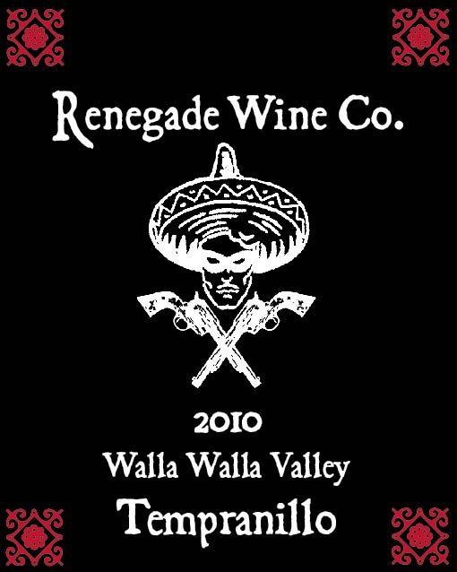

The Renegade Wine Co. is very excited to release our first Tempranillo! 125 cases of this unique (to Washington State) varietal were produced. This wine has all the trademark characteristics of Tempranillo, from its medium ruby red color, to the perfumey, red berry nose, along with vanilla and tobacco notes. There is terrific acidity, balanced with a plush tannin profile, and provides great structure for mid-term aging. This is a fun wine to throw into a blind Rioja tasting, and at this price, you’ve got nothing to lose! Be a Renegade!
Release date June 1st, 2012

